Splash Page (Drayton Bird - 'Commonsense Direct & Digital Marketing')
Съдържание
Отправен материал 2
Разяснения 2
WordPress. Splash-Страница 3
WordPress. Very Simple Splash Page Plugin 4
Description 4
Screenshots 6
FAQ 7
Contributors & Developers 8
Simple Splash Demo 8

Отправен материал
https://github.com/VelinSkenderov/HTML-Task_20170221-/blob/master/WEB%20Analytics/WordPress/PRESENTATION/Drayton Bird - 'Commonsense Direct Marketing', 4th Edition.pdf:
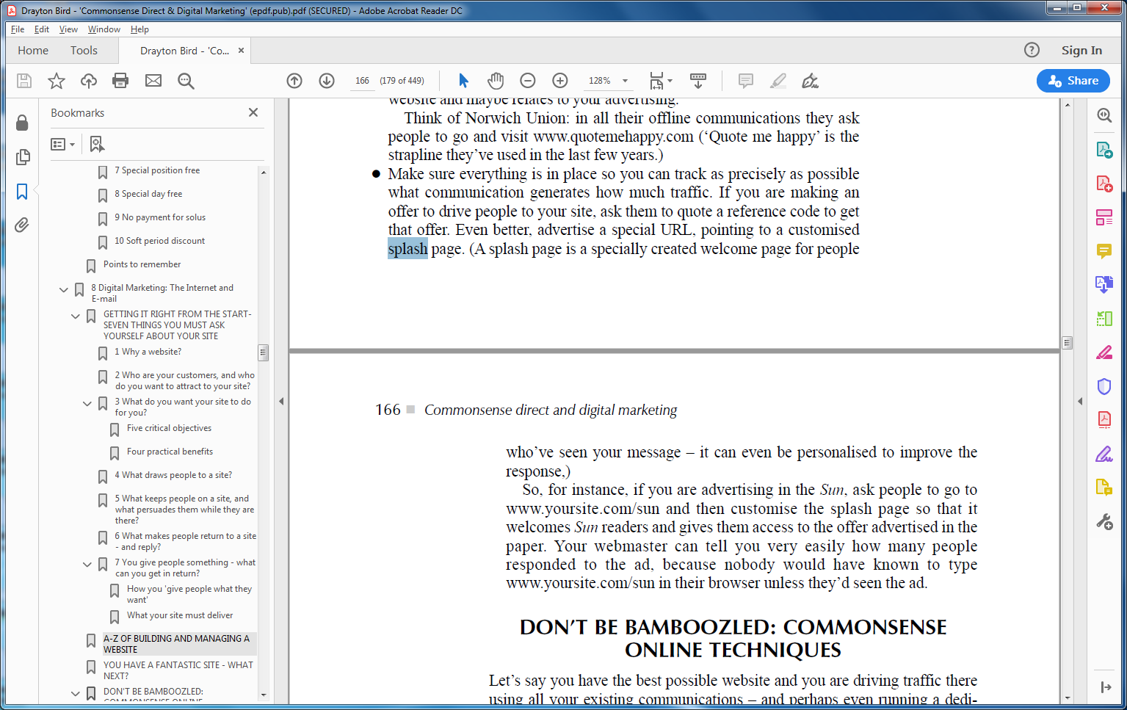

Разяснения
Следва да заложим възможност максимално стриктно да проследяваме какъв Трафик генерира всеки елемент от нашия Комуникационен процес. Ако посетителите са привлечени от наша Оферта, ги поощряваме да предоставят нейн референтен Код. Още по-удачно е избирателно да пубикуваме URL-Адреса на съответна Splash-Страница. (Splash-Страницата е индивидуално изготвена Welcome Page/Начална Страница за Посетители, привлечени от конкретно Послание – която допълнително персонализираме, с оглед да получим повече отговори от Респонденти.)
Ако, например, рекламираме във вестник Sun, поощряваме представителите на Аудиторията да посетят www.нашсайт.com/sun, приветстваме ги на специална Splash-Страница за читатели на Sun, на която те получават достъп до Офертата, рекламирана във вестника. От нашия Мрежови администратор (Webmaster), лесно можем да разберем броя посетители, привлечени от Рекламата, защото трети лица не биха въвели Адреса www.нашсайт.com/sun в своя Browser при положение, че не са видели рекламата.

WordPress. Splash-Страница
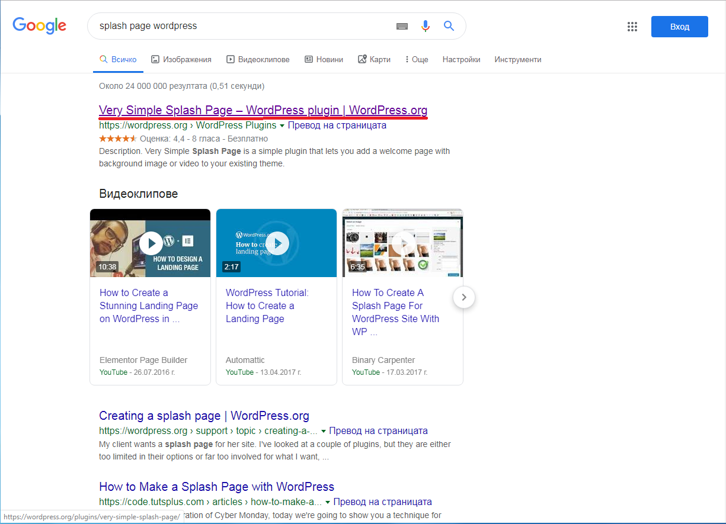

WordPress. Very Simple Splash Page Plugin
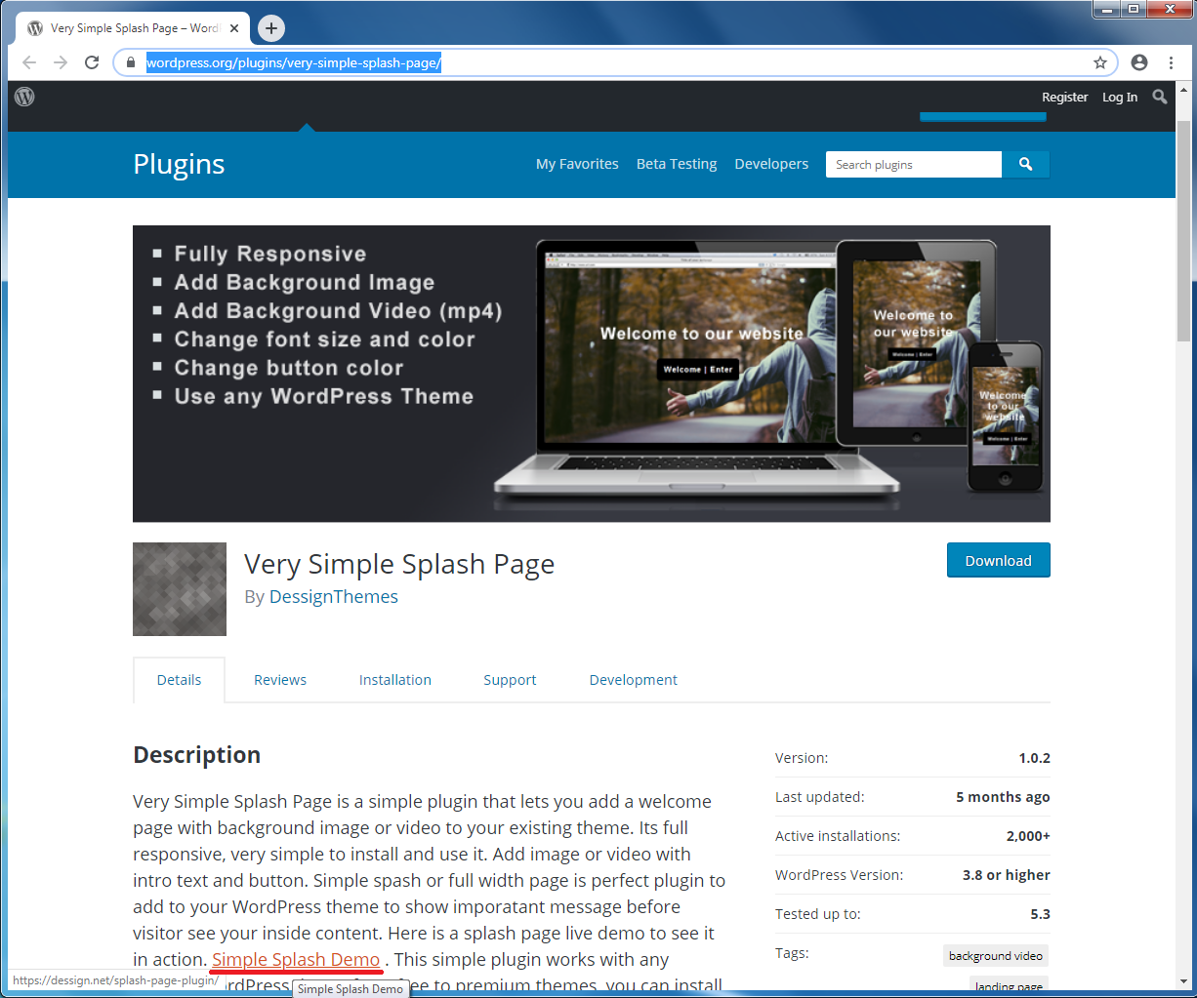

Description
Very Simple Splash Page е опростен Plugin, чрез който добавяме Welcome Page/Начална Страница с Background-Изображение или Видео към вече заложена Theme-а на нашия Сайт. НАПЪЛНО Адаптивен (Fully Responsive) е и изключително удобен за Инсталиране и Използване. Можем да добавим Изображение или Видео с Интро-Текст/Бутон. Предоставяйки ни най-обикновена страничка или
Very Simple Splash Page is a simple plugin that lets you add a welcome page with background image or video to your existing theme. Its full responsive, very simple to install and use it. Add image or video with intro text and button. Simple spash or full width page is perfect plugin to add to your WordPress theme to show imporatant message before visitor see your inside content. Here is a splash page live demo to see it in action. Simple Splash Demo . This simple plugin works with any existing WordPress theme from free to premium themes, you can install any theme on top on Very simple splash page. We also have a great resources of free and premium WordPress themes you can use with Very simple spash page. Also since WordPress 5.0 release and introduction of Gutenberg page builder we also have a Free Gutenberg Starter Theme which is great and works perfect with the simple splash page giving you ability to build on the new gutenberg page builder theme. Gutenberg is the future of WordPress block building experience, and its perfect for any beginner or advanced WordPress user looking to create and design gutenberg compatible and ready websites.
With simple spash page plugin, you can customize the feel and look of buttons, fonts, colors, and upload any photo you like. Also you can upload your favorite mp4 video. It gives you ability to upload nay mp4 video if you liketo have a video background instead of photo. Make sure to upload short mp4 so your page don’t take too much time to load. As many people move into background video motion this is perfect simple plugin to give you ability to show quick preview of your beutiful video before anyone enters your main website.
One you have your very simple spash page plugin install and you pick your free or premium theme, make sure your website is running on great hosting. When using large fullscreen image or video background you need to have reliable WordPress hosting that can handle and open your website in seconds as this is major positive point in Google ranking your website based on page speed. We would only recommend to have a WordPress hosting recommended by WordPress itself which is Bluehost and Siteground two of the best hosting solutions when it comes to WordPress sites. As we partner with both of those hosting companies we offer a discount for those two amazing hosting solutions. With Bluehost coupon you can take adventage of amazing discount on your hositng and also with Siteground coupon you can save on any WordPress hosting solutions and help you save and grow your website business.
Very simple splash page will give your website a nice and welcome appearance, where you can direct visitors to specific pages or posts on your website. You can simple introduce them to your favorite page on website which could be your about page, so they will get to know the person behind the blog or site you build. If you running a online business simple splash page plugin can add promotion or discount to your landing page, so customers can see your special offers. Or you can redirect your first time visitors to a clearance or sale page where they can get amazing discounts on your product.If you thinking about opening a WooCommerce ecommerce store we have a list of Free WooCommerce themes you can use and they work with very simple splash page, they are all 100% free and perfect solution to get starter on your ecommerce business.
Features:
- Fully Responsive
- Add Background Image
- Add Background Video (mp4)
- Change font size and color
- Change button color
- Works with every WordPress Theme

Screenshots

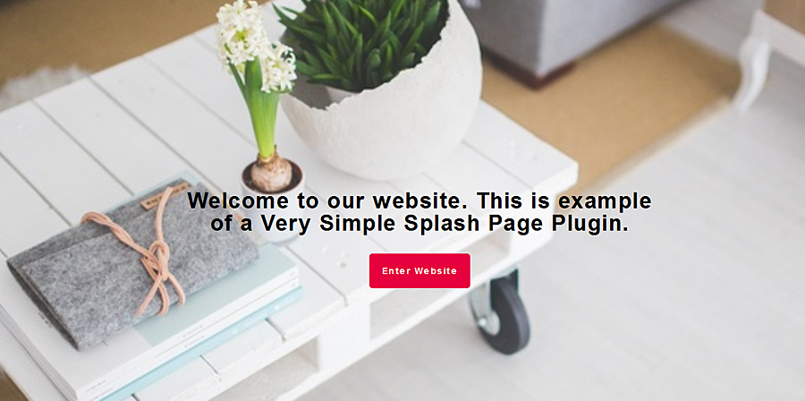

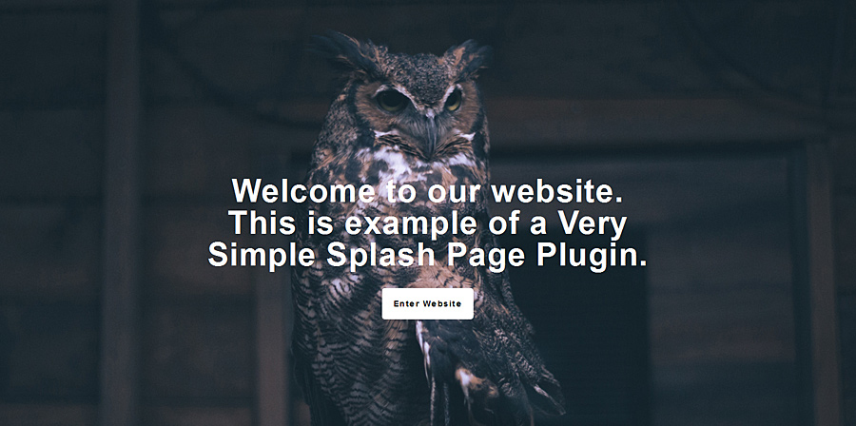

FAQ
Q: Can I use this plugin with any WordPress Theme?
A: Yes
Q: Is it Responsive?
A: Yes
Q: Can I add Video as Background?
A: Yes, mp4 format

Contributors & Developers
“Very Simple Splash Page” is open source software. The following people have contributed to this plugin.

Simple Splash Demo
